men and machines
All Words & Music: © Darren Poyzer . www.poyzer.com . tel 07866 507441
I'm seriously thinking of faking my death
And just living for the Summers we have left
Here in our lives
Wiping a tear of loss from my eyes
All I had were Men and Machines
Shaping my nightmares and dreams
Now your love has given me wings
I can glide on the breeze
I'm seriously thinking of just letting go
Of the charts and the maps that lead me from home
The things that divide us are fuel for the fire
A beacon of hope, a heart of desire
For all that it's worth
Protecting our children at birth
From the call of the men and machines
Experiments in whole new extremes
Consuming much more than they need
As they burn, on the breeze
History shows there's no light at the end of their day
Just the slaves and the graves of the millions who get in the way
As men and machines, fight with men and machines
As men and machines, steal from men and machines
So that men and machines
Can go about their business, whatever that means
I'm seriously thinking of faking my death
And just living for the Summers we have left
Here in our lives
Wiping a tear of loss from your eyes
All I had were Men and Machines
Shaping my nightmares and dreams
Now your love has given me wings
I can glide on the breeze
~ ~ ~
men and machines
All Words & Music: © Darren Poyzer . www.poyzer.com . tel 07866 507441
Guitar chord shapes used in this song:
(Normal tuning / capo 5th fret or as you prefer)

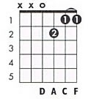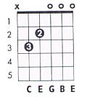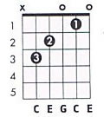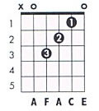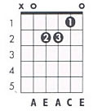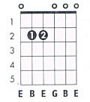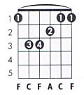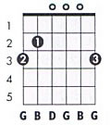

There are one or two important ‘runs’ on the bass line, and a couple of finger flicks to look out for.

Most notably:

the opening verse sequence which begins with the Dm7 shape, runs via a G bass note to the Cmaj7

the line “all I had were men and machines” runs down from a G bass note to an F# bass note

Furthermore the C and Fmaj7 chords frequently use a ‘2nd finger flick’ technique whereby the chord is slightly altered by the brief removal of the 2nd finger from the chord.

~ ~ ~

‘Men And Machines’ was first recorded and featured on the ‘Brilliant Words’ album.

These chords and lyrics compliment the Songbook video at www.poyzer.com

